NBKRIST
BASIC ELECTRICAL SCIENCES
LECTURE NOTES
UNIT-5
I.PRABHAKAR REDDY
DEPARTMENT OF ELECTRICAL AND ELECTRONICS ENGINEERING

Magnetic Circuits
FARADAY'S LAWS OF E LECTROMAGN ETIC INDUCTION:
Faraday's laws state that an emfis induced in a circuit which is
(i) Directly proportional to the time rate of change of flux enclosed by the circuit.
(ii) Directly proportional to N the no. of turns of the circuit.
Combining, the two laws, Faraday's laws of induction can be expressed mathematically as
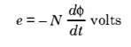
Here negative sign is due to Emil Lenz, who subsequent to Faraday's experiments suggested
that the direction of the induced current is always such as to oppose the action that produced it.
As we know Faraday's law as given by equation (ii. 1) is one of the two basic relationships
upon which the whole theory of electromagnetic and electromechanical energy conversion devices
are based and today we have the generator and motor (electric) operating based on this theory.
Also Faraday was the first to identify emf of self-induction, i.e., here we have only one coil
and it is connected to a de source through a switch. When current is flowing through this coil
and the circuit interrupted through the switch an emf is induced in the coil. This is known as
emf of self-induction expressed mathematically
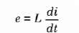
Where L is a proportionality constant called the co-eﬀicient of self-inductance which depends
upon the medium and other physical parameter.
The circuits we have considered so far may be regarded as conductively coupled, because one loop affects the neighboring loop through current conduction. When two loops with or without contacts between them affect each other through the magnetic ﬁeld generated by one of them, they are said to be magnetically coupled.
The transformer is an electrical device designed on the basis of the concept of magnetic coupling. It uses magnetically coupled coils to transfer energy from one circuit to another. Transformers are key circuit elements.
Self Inductance
Self inductance is the ration between the induced Electro Motive Force (EMF) across a coil to the rate of change of current through this coil. Self inductance is related term to self induction phenomenon. Because of self induction self inductance generates. Self-inductance or Co-efficient of Self-induction is denoted as L. Its unit is Henry (H). First we have to know what self induction is. Self induction is the phenomenon by which in a coil a change in electric current produces an induced Electro Motive Force across this coil itself. This induced Electro Motive Force (ε) across this coil is proportional to the current changing rate. The higher the rate of change in current, the higher the value of EMF.
We can write that,
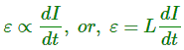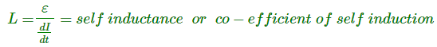
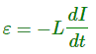
But the actual equation is This Induced EMF across this coil is always opposite to the direction of the rate of change of current as per Lenz’s Law.
When current (I) flows through a coil some electric flux produces inside the coil in the direction of the current flowing. At that moment of self induction phenomenon, the induced EMF generates to oppose this rate of change of current in that coil. So their values are same but sign differs. Look at the figure below.
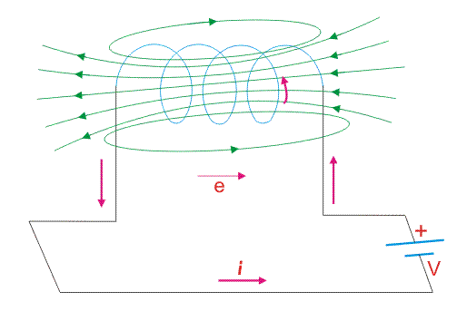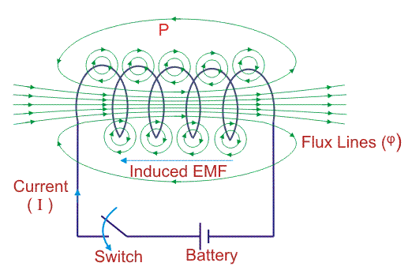
Take a closer look at a coil that is carrying current. The magnetic field forms concentric loops that surround the wire and join to form larger loops that surround the coil. When the current increases in one loop the expanding magnetic field will cut across some or all of the neighboring loops of wire, inducing a voltage in these loops.
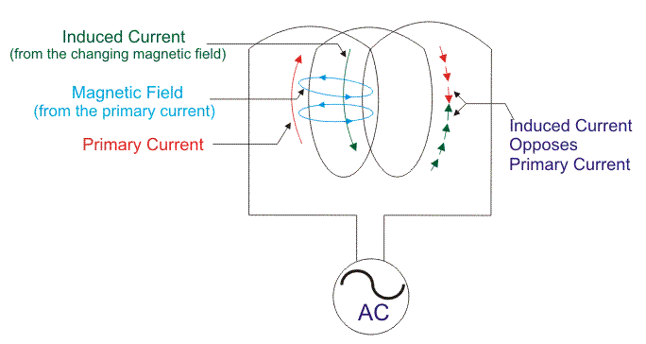

Mutual Inductance
Mutual Inductance is the ratio between induced Electro Motive Force across a coil to the rate of change of current of another adjacent coil in such a way that two coils are in possibility of flux linkage.Mutual induction is a phenomenon when a coil gets induced in EMF across it due to rate of change current in adjacent coil in such a way that the flux of one coil current gets linkage of another coil. Mutual inductance is denoted as ( M ), it is called co-efficient of Mutual Induction between two coils.
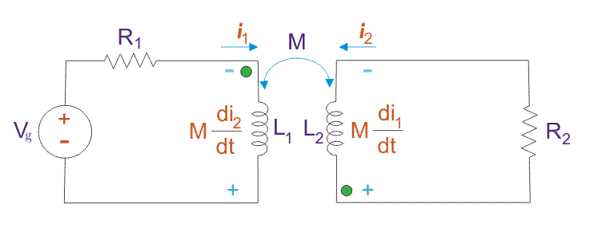Mutual inductance for two coils gives the same value when they are in mutual induction with each other. Induction in one coil due to its own rate of change of current is called self inductance (L), but due to rate of change of current of adjacent coil it gives mutual inductance (M).
From the above figure, first coil carries current i₁ and its self inductance is L₁. Along with its self inductance it has to face mutual induction due to rate of change of current i₂ in the second coil. Same case happens in the second coil also. Dot convention is used to mark the polarity of the mutual induction. Suppose two coils are placed nearby.
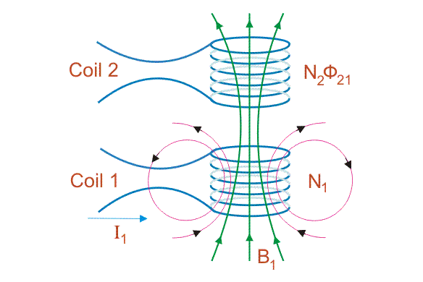
Coil 1 carries I₁ current having N₁ number of turn. Now the flux density created by the coil 1 is B₁. Coil 2 with N₂ number of turn gets linked with this flux from coil 1. So flux linkage in coil 2 is N₂ . φ₂₁ [φ₂₁ is called leakage flux in coil 2 due to coil 1].
Consider φ₂₁ is also changing with respect to time, so an EMF appears across coil 2. This EMF is called mutually induced EMF.
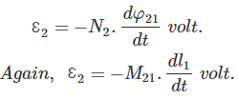
Now it can be written from these equations,
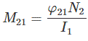
Again, coil 1 gets induced by flux from coil 2 due to current I2 in the coil 2. 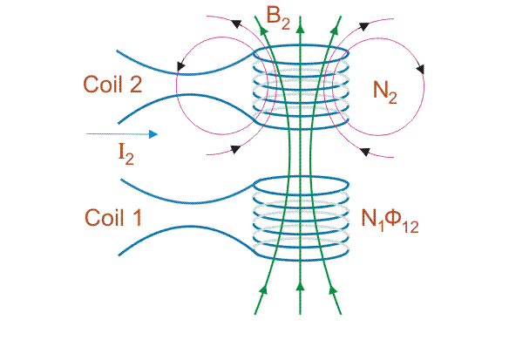
In same manner it can be written that for coil 1.
However, using the reciprocity theorem which combines Ampere’s law and the Biot-Savart law, one may show that the constants are equal. i.e. M₁₂ = M₂₁ = M. M is the mutual inductance for both coil in Henry. The value of mutual inductance is a function of the self-inductances Suppose two coils are place nearby such that they are in mutual induction. L₁ and L₂ are co-efficient of self-induction of them. M is the mutual inductance. 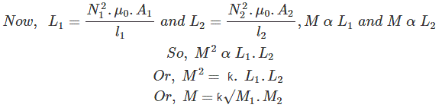Here, ƙ is called co-efficient of coupling and it is defined as the ratio of mutual inductance actually present between the two coils to the maximum possible value. If the flux due to first coil completely links with second coil, then ƙ = 1, then two coils are tightly coupled. Again if no linkage at all then ƙ = 0 and hence two coils are magnetically isolated. Merits and demerits of mutual inductance: Due to mutual inductance, transformer establishes its operating principle. But due to mutual inductance, in any circuit having inductors, has to face extra voltage drop.
Dot Convention
The self-inductance of a circuit is intimately associated with the magnetic field linking the circuit. The self-inductance emf may be thought of as the emf induced in the circuit by a magnetic field produced by the circuit current.
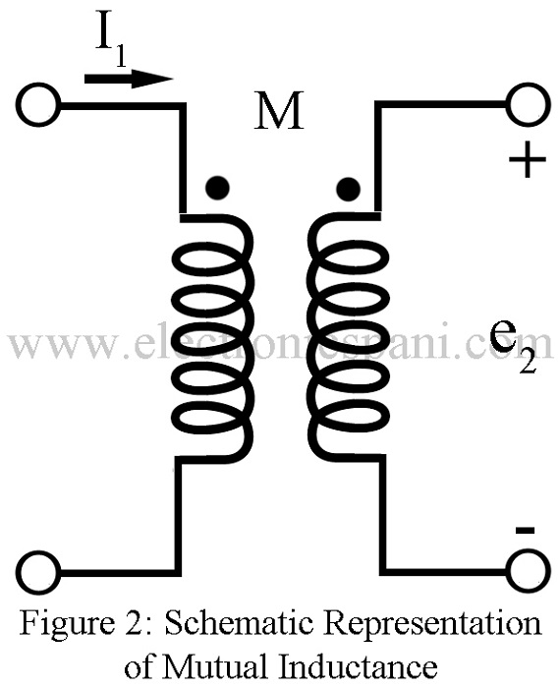
Fig .5.2
Since a magnetic field exists in the region around the current that develops it, there is also may a possibility that an emf be induced in the other circuits linked by the field. Two circuits linked by the same magnetic field are said to be coupled to each other. The circuit element used to represent magnetic coupling is shown in Figure 5.2 and is called mutual inductance. It is represented by symbol M and is measured in henrys. The volt-ampere relationship is one which gives the induced emf in one circuit by a current in another and is given as
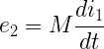
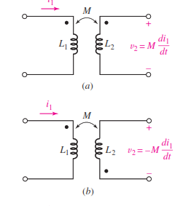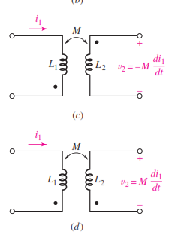
How to find out L_{eq} in a circuit having mutual inductance with dot convention Suppose two coils are in series with same place dot.
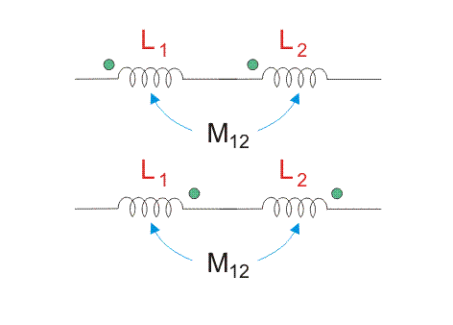
Mutual inductance between them is positive.
Suppose two coils are in series with opposite place dot.
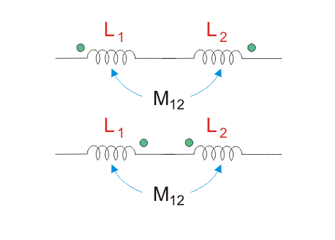
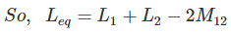
When a few numbers of inductors are in series with mutual inductances.
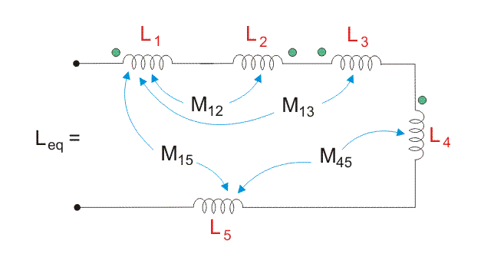
Inductor in parallel
Let us consider two coils of inductance L1 and L₂ connected in parallel as shown in figure 8
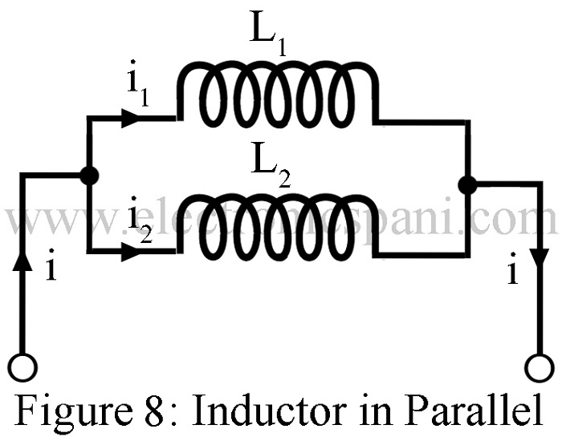
The supply circuit divides into two components i₁ and i₂ following through the coils.
i.e.
or 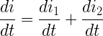
Self-induced emf in coil A, 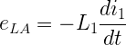
Mutually induced emf in coil A due to change of current in coil B,
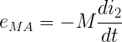
Where M is the mutual coefficient of inductance
Resultant emf induced in coil A,
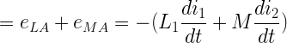
Similarly, resultant emf induced in coil B
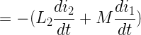
As both coils are connected in parallel, therefore, resultant emf induced in both of the coils must be equal
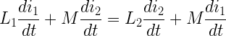

Or 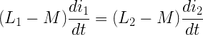
Or 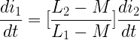 ……(11)
Or 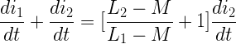
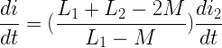 ……(12)
If L is the equivalent inductance of the combination then induced emf
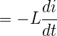
Since induced emf in parallel combination = Induced emf in either of the coils.
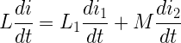
Or
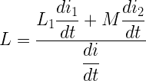
Substituting from equation (11) and 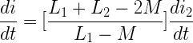from equation (12) we get
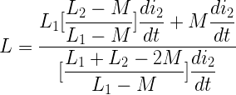

Or 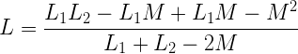
Or 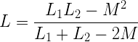
When mutual flux helps the individual flux
Or 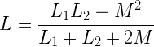
When mutual flux opposes the individual flux.

